Individual Weekly Report for Sam Baranov

Gym App

July 28, 2025

# Accomplishments

* Created a high fidelity, low scope Figma prototype using Material 3 elements so as to be directly transferable to Flutter
* Completed UI Expert meeting
* Completed Stakeholder meeting
* Presented Showcase 2
* Implemented entities and database for Drift
* Adjusted development based on the timeline
* Finalized design specification document

# Weekly Activities

| Activity / Task / Work | Hours | Status |
| --- | --- | --- |
| Figma prototype high fidelity work | 14 | Complete |
| UI expert meeting | 2 | Complete |
| Stakeholder meeting | 0.5 | Complete |
| Showcase 2 | 2.5 | Complete |
| Implemented entities and MVP database with drift | 8.5 | In progress |
| Development plan adjustments | 1.5 | Complete |
| Design specifications finalized | 9.5 | Complete |
| Implementing UI in flutter | 2 | Complete |
| Status Report week 5 | 1.5 | Complete |
| Contract draft | 0.5 | In progress |
| **Weekly Total** | **42** |  |
| Previous Weekly Cumulative Total (Carry Over) | 55 |
| **Current Cumulative Total** | **97** |

# Plans for Next Week

| Activity / Task / Work | Est Hours |
| --- | --- |
| Domain layer work | 3 |
| Finalize contract | 3 |
| UI implementation | 10-15 |
| Database implementation | 3 |

# Response to Feedback

A lot of feedback has been collected over the last two weeks.

Biggest piece of feedback was from the UI expert. The suggestion was to stop trying to fully outline the prototype, and instead pick the best screens from the prototype, develop them into implementable state, and implement in Flutter. This has already been implemented into the new plan, and it is how I am continuing going forward.

Stakeholder interview admittedly wasn’t particularly informative, although I did got a good counter to some of the points that were outlined in the expert interview. Main one being that UI expert thought that information is too dense, while the stakeholder found that it was actually the thing that made them interested in the app, as the absence of detail is the main reason they use paper tracking instead. However, there wasn’t much other information, aside from some fitness-specific feedback on metrics and UI inclusions.

Showcase presentation provided feedback that reinforced my choice to pivot into working on the actual code without completing the final prototype version. Another important piece of information from showcase was in regards to scope of the project for the first quarter. I overshot with what I intended to finish by the end of the quarter, and now changed the scope.

# Other Reflections

I missed last week’s status due to a lot of personal life things (my girlfriend’s cat might be dying, and my work was celebrating 10 years of the company), so I compressed it into here.

I finally managed to create a UI design for at least the core screens that I like. I ended up redoing the Material 3 Figma prototype, mostly because I kept discovering better and better ways to do the same things. This has probably been the most complicated part of this project so far, but I expect the programming to be far easier, now that I have specific direction.

From feedback, I have ended up changing the scope of the project for this quarter, to create a dummy version of the app, for now.

I’ve been going through database and entity design in flutter, and I have opted in for simplifying it for now, so as to make it easier for the prototype version for this quarter. I will migrate the database later.

Also, finishing design specification took far, far longer than I could have anticipated. I ended up rewriting a lot of parts for clarity, as well as cleaning up the diagrams, and it basically took an entire day.

# Comments, Issues, Notes, Anything Else?

There has been a lot of personal problems, so I expected a large loss of time, but I actually ended up going slightly over time.

I ended up not doing last status, since I can skip 2 according to the syllabus, and I admittedly didn’t have time for that.

# Evidence of Work

## Figma Prototype Work

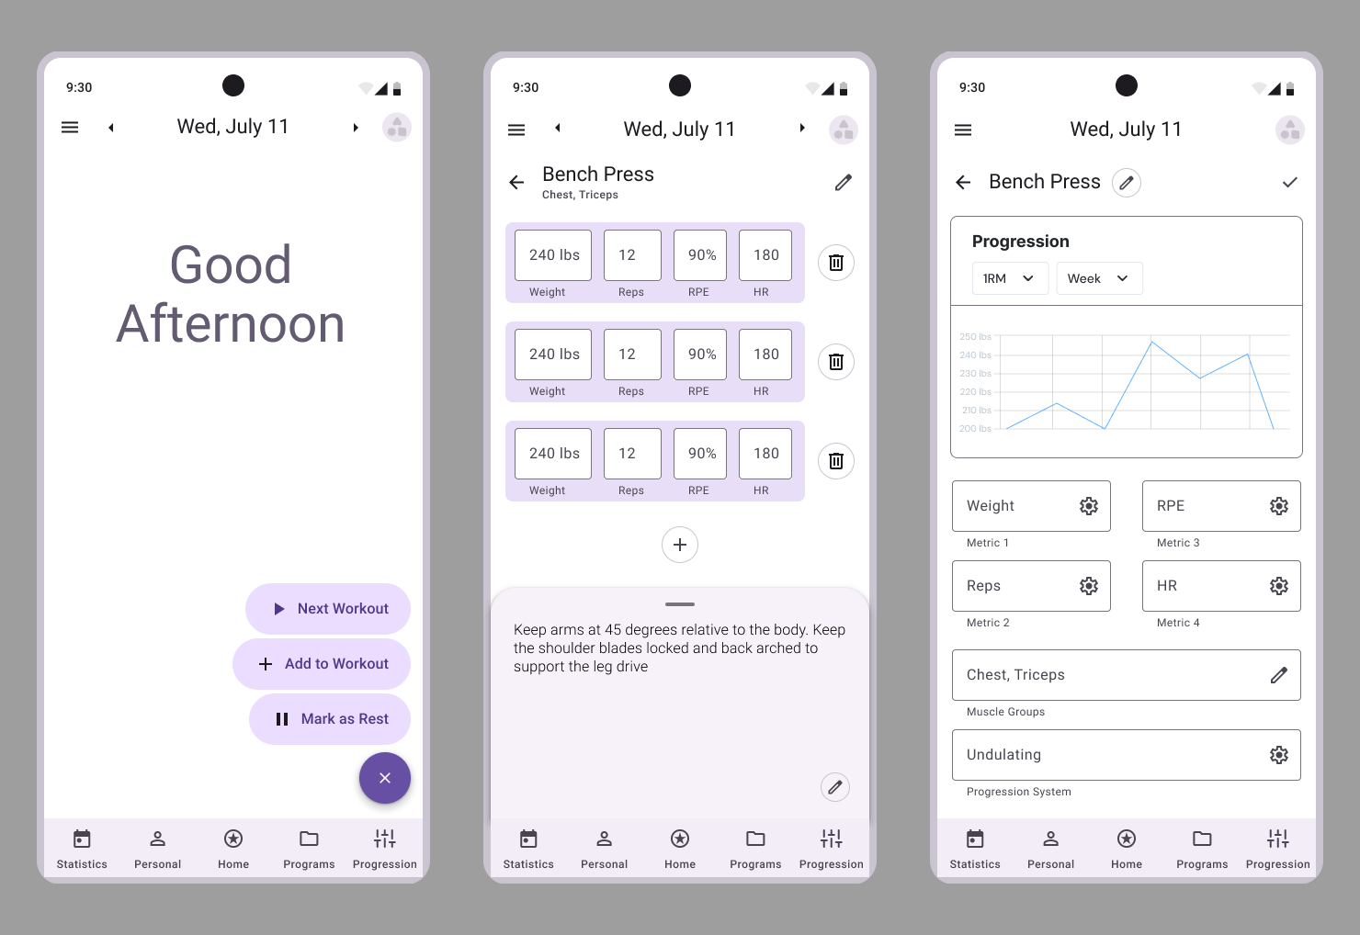

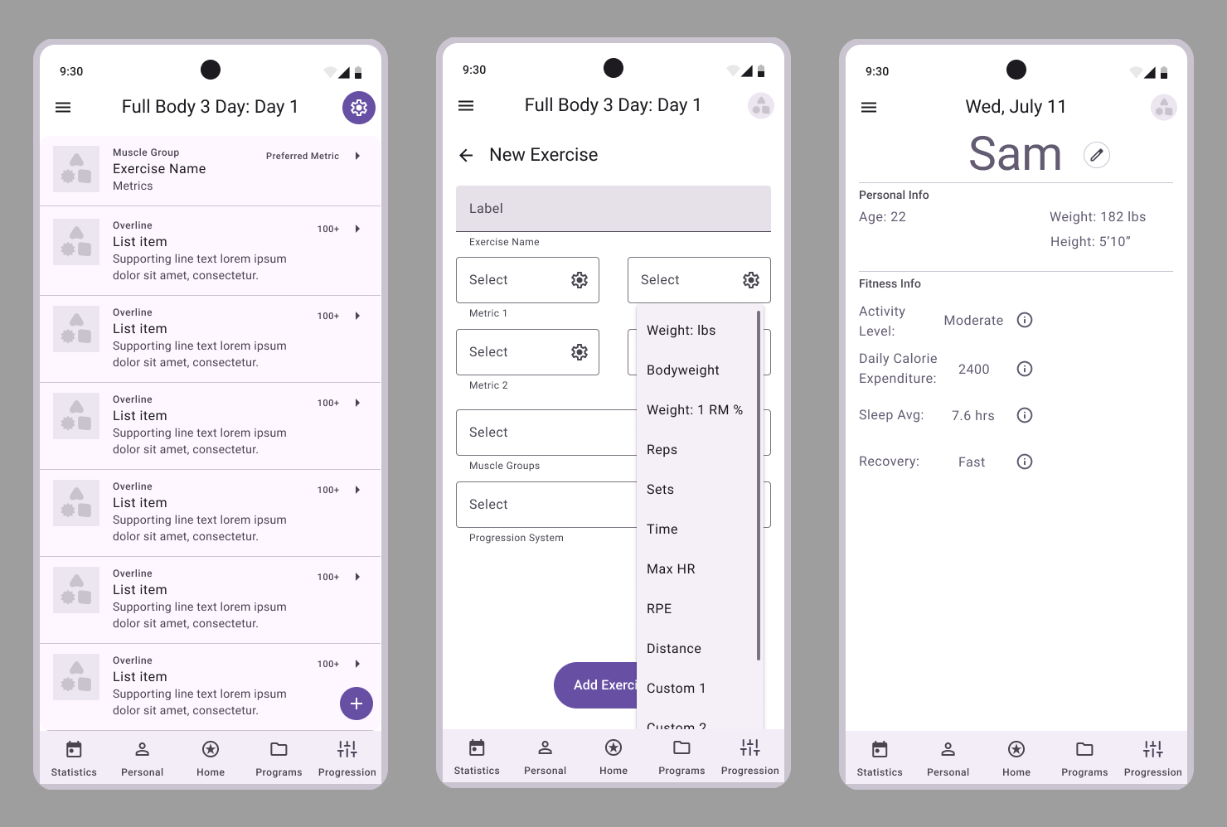

These are the core screens that the UI expert recommended focusing on implementing.

Overall polished UI screens.

Database schema based on design doc.

*Informational interview*

# Interaction Report

Interaction Type: Expert

Interaction Date: 7/18/2025

Attendees: UI Expert

## Summary of Interaction

The meeting was an in-person meeting in a café, where I showed a UI designer friend my prototypes, as well as discussing my overall project. The discussion ended up lasting way longer than expected.

The person interviewed was a UI designer, who has experience with professional Android development in modern frameworks (primarily Compose, but also Flutter), and has done projects similar in scope to mine, in the free time.

I got a wide variety of feedback on individual screens and design elements, as well as a lot of overall project direction and organization feedback. The primary takeaways were to pivot into building a working, if dummy, screens and enforcing a strict visual pattern early on, so as to streamline future development by creating highly reusable widgets.

## Action Items

* Review the project plan for this quarter
* Begin implementing the current state of prototype in Flutter
* Review the density of UI for real world devices
* Check the viability of screen navigation with this many elements
* Review the screen flow from performance perspective
* Create uniform “action” button
* Check the icon consistency in actual Flutter
* Create a color theme for dark mode

## Reflection on the Interaction

I got an extreme amount of actual practical design feedback on the prototype details, as well as an extended amount of feedback in on the overall project direction. This was initially supposed to be a short meeting, but ended up spanning around 2 hours, and it significantly pivoted the direction of the project for this quarter. I am now planning to cut down on the features, and instead attempting to implement a detailed UI framework that can be reused for the rest of the screens. The plan is now to get to the UI programming as soon as possible and focus on few quality screens with reusable structures.

# Interaction Report

Interaction Type: Stakeholder

Interaction Date: 7/27/2025

Attendees: Local gym owner, Stakeholder

## Summary of Interaction

This was a short interview at the gym I go to, with the gym owner, who also occasionally plays the role of trainer. The interview was relatively short, where I outlined the overall concept of the project, shown the prototype and UI design, and discussed overall viability of the project.

The owner ended up not being a big fan of fitness apps as a whole, but did have positive feedback to the intended information density of the proposed project. I ended up with some general suggestions that reinforced some of the ideas that I initially got critiqued on by the UI expert, primarily the cluttered feel of the overall prototype, as well as the idea to limit the metrics to a wide selection of pre-defined ones, instead of giving complete free reign to the user.

## Action Items

* Go on with the proposed project idea
* Review possible simplified options for the automated features, to support more manual control of the fitness plans
* Focus on data visualization more, as that would be one of the main selling points to paper-only users.

## Reflection on the Interaction

I learned a perspective of a user that doesn’t actually use competitor apps, and instead represents someone who generally has an unbiased perspective on the topic. As such, I got feedback on some of the main features that could possible convince current non-users to actually migrate to a phone-assisted tracking approach. I got some feedback that contradicted the industry expert, primarily surrounding the unusually high UI density, as well as prioritization of modeling features as a main selling point.

# Interaction Report

Interaction Type: Instructor

Interaction Date: 7/23/2025

Attendees: Class showcase

## Summary of Interaction

This was the in-class showcase on Wednesday. I got some feedback that reinforced the suggested pivot to implementation before prototype completion, as well as clarification on the scope of the project for the first quarter.

## Action Items

* Begin implementing UI in Flutter as soon as possible
* Focus on creating a dummy prototype with quality UI by the end of the quarter, instead of more algorithmically complex version.

## Reflection on the Interaction

Overall, this interaction reinforced a lot of the ideas I already had by this point, and gave me a go-ahead on beginning working on the programming part of the project.